**17 Write a Prolog Program to Sum the Integers from 1 to n.**

**AIM**

To write a Prolog program that computes the sum of integers from 1 to N.

**ALGORITHM**

1. If N = 0, then sum = 0. (Base case)
2. Otherwise, recursively compute sum(N-1) and add N.
3. Return the final sum.

**CODE**

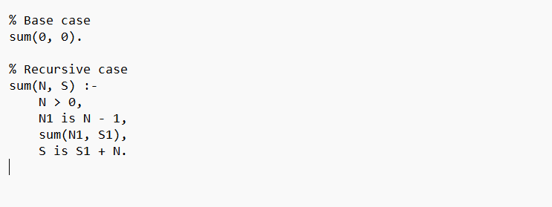

**OUTPUT**

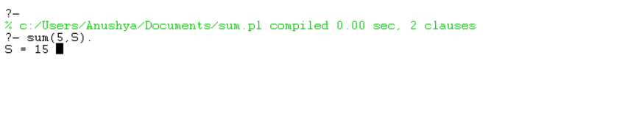

**RESULT**

The program successfully computes the sum of integers from 1 to N using recursion in Prolog.